**ACTIVITY – 3**

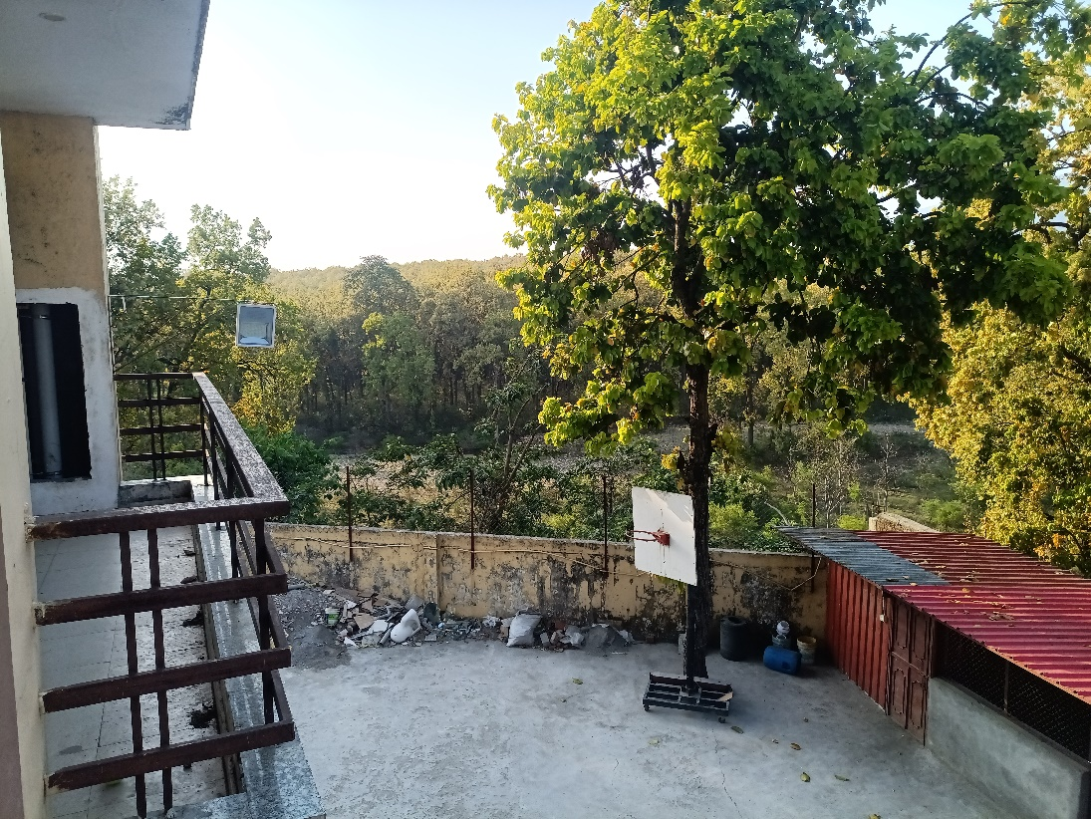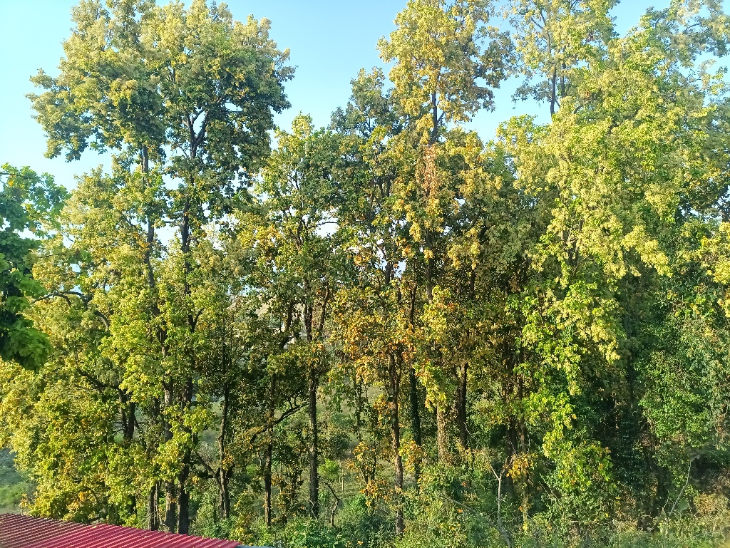In this activity we have observe the following forest near our hostel. The pics arew as follows:

On the basis of this forest we have observe the following:

1. **PRODUCERS:** Producers are any kind of green plant. Green plants make their food by taking sunlight and using the energy to make sugar.

So in our case forest are the producers and the pics are as follows:

1. **CONSUMERS:** Consumers constitute the upper trophic levels. Unlike producers, they cannot make their own food. To get energy, they eat plants or other animals, while some eat both.

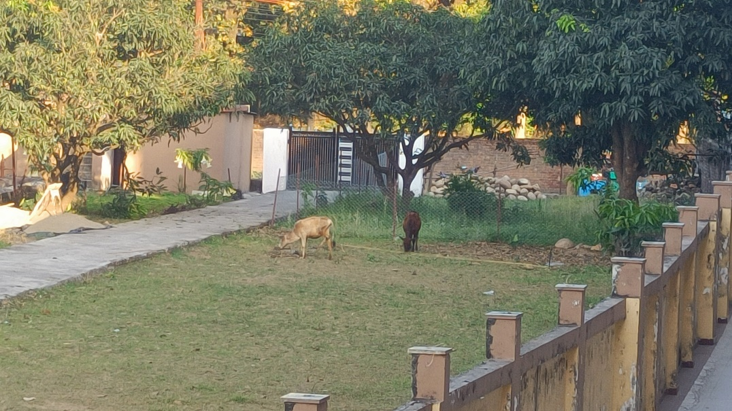So in our case cows and monkeys are the consumers in that particular ecosystem.

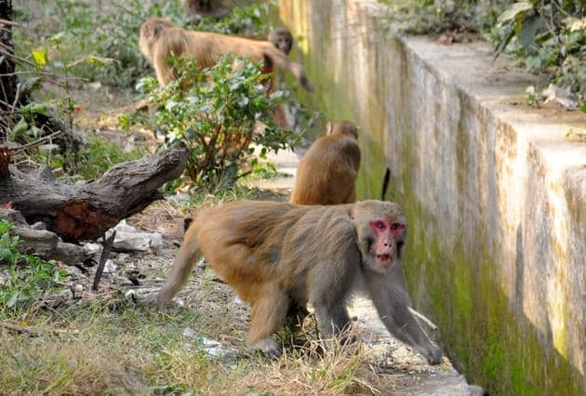

1. **DECOMPOSERS:** Decomposers decompose dead plants and animals and hence act as cleansing agents of the environment.

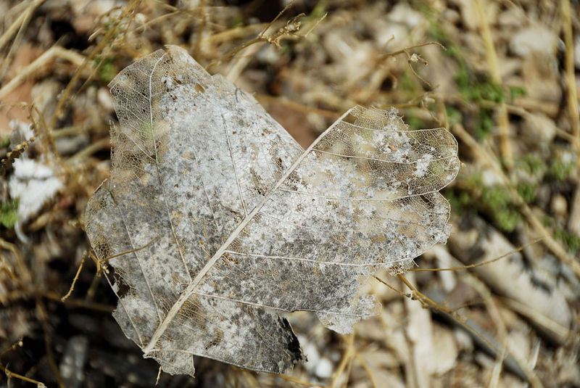So in our case the decomposers are fungi and living organism in that particular area.

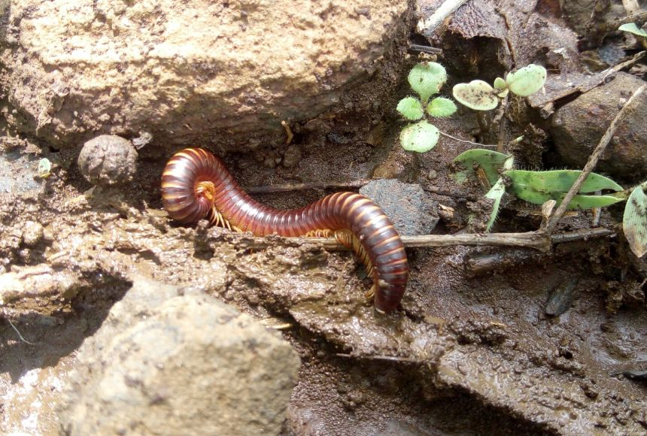

**MADE BY:**

**NAME OF TEAM MEMEBERS** **SAP ID** **BATCH**

HITENDRA SISODIA 500091910 B - 2

KARTIKAY KANOJIA 500090998 B - 1

ANIRUDH SRINIVASAN 500091739 B – 2

UJESH SISODIA 500091882 B - 2

PRIYANSHU TANDON 500091901 B - 2